## INFO1195 – Data Management for GIS (GIS 3)

## Assignment – Practical (Postal Code conversion File)

## <<Registered Full Name>> <<Student ID>>

## Description

Please look at research activities in the [**Social Innovation Hub**](https://research.conestogac.on.ca/conestoga-social-innovation-lab) at Conestoga College. They're looking for socioeconomic parameters that contribute to the community using GIS technology and skills. For example, check the list of CSIL publications and achieve.

Think about what kind of open data source with the GIS technology and knowledge could contribute to their community-based approach in support of communities and organizations.

## Rationale – Course Learning Outcomes

CLO1: Apply data fundamentals to collect, collate, cleanse and prepare data for geospatial analysis.

CLO2: Choose geospatial data from commonly used data sources.

## Directions

1. Check the [**Postal Code Conversion File**](https://www150.statcan.gc.ca/n1/en/catalogue/92-154-X) (PCCF), which aligns with Canadian Postal Codes and Statistics Canada’s standard geographic areas. The PCCP associates each postal code with a longitude and latitude coordinate to support mapping applications.
2. Please check the [Postal code conversion file | Map and Data Library](https://mdl.library.utoronto.ca/collections/numeric-data/census-canada/postal-code-conversion-file) provided by the University of Toronto. The [presentation](https://borealisdata.ca/dataset.xhtml?persistentId=doi:10.5683/SP3/4N4CIM) about the PCCP products would be helpful.
3. Test [**Land Cover of Canada**](https://open.canada.ca/data/en/dataset/ee1580ab-a23d-4f86-a09b-79763677eb47) information through the Open Government Portal. Navigate the information on legends and geometric components with QGIS tools.
4. Explore the [**National Land Cover Database**](https://www.usgs.gov/node/279743) (NLCD) through the United States Geological Survey (USGS).
5. Compare and contrast those datasets in highly densely populated areas with PCCF data.
6. Use [APA 7th edition citations](https://mcas-proxyweb.mcas.ms/certificate-checker?login=false&originalUrl=https%3A%2F%2Flib.conestogac.on.ca.mcas.ms%2Fapa-conestoga%3FMcasTsid%3D15600&McasCSRF=6d685479caf7ba0a7548ec9a2f7dc65a04232e3699d3644aae4b5fa090701ca6) and references.

## Rubrics

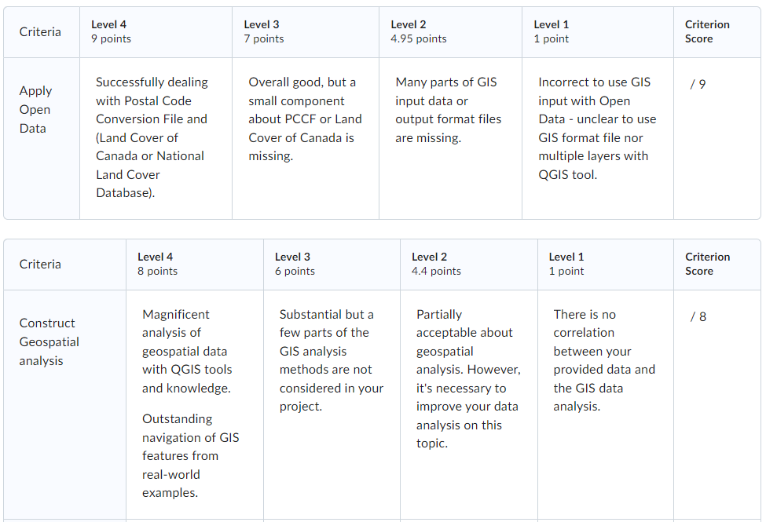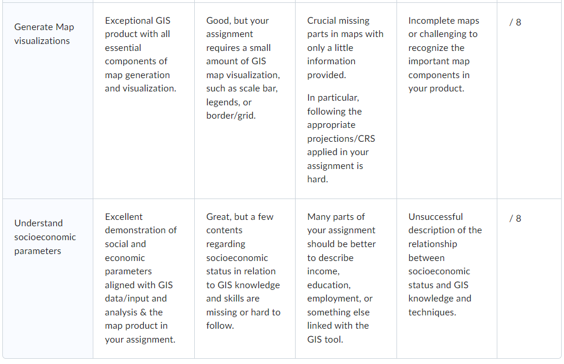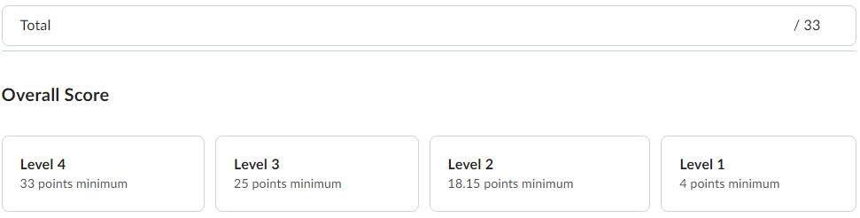

## Evaluation

You will be graded based on the following rubric for the eConestoga in this course (INFO1195). Go to Course Tools/Rubrics for the Assignment – Practical 2.